Salesforce Administrator Self-Learning & Super Badges

[**SECURITY SPECIALIST - SUPERBADGE**](https://smartinternz.com/Student/guided_project_workspace/47025#collapse4)

# Data Security

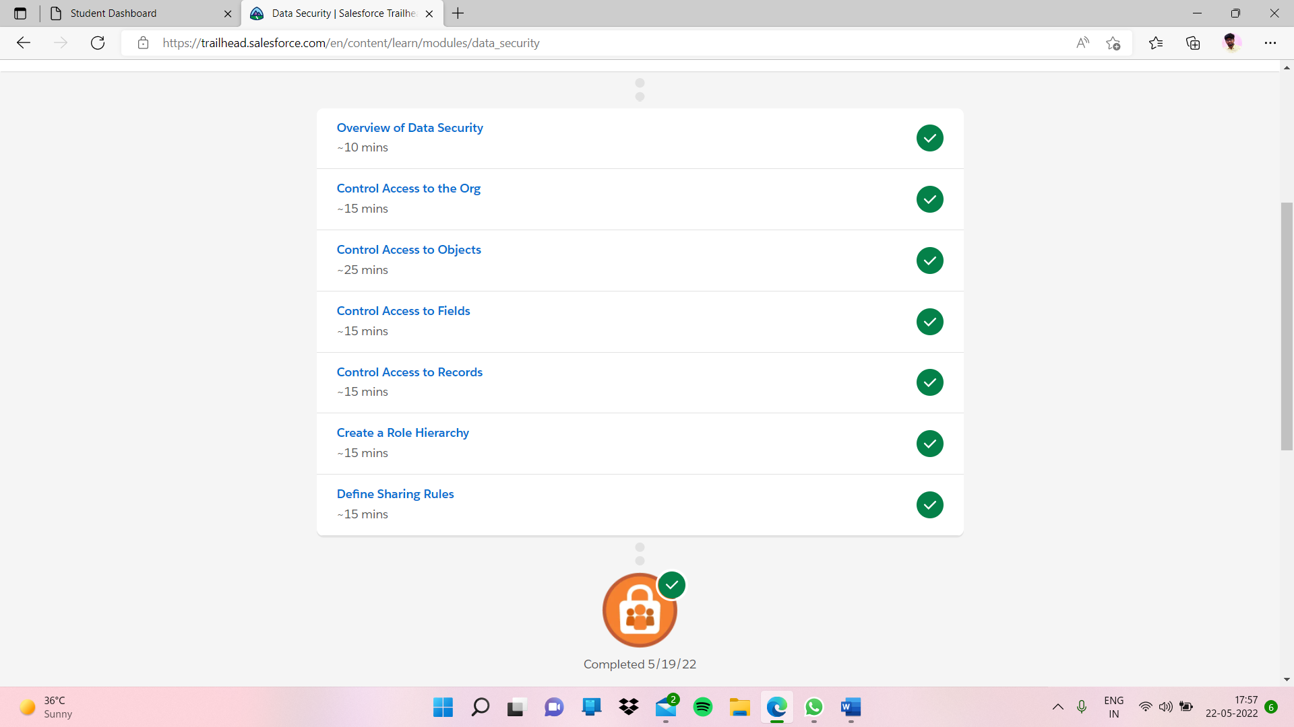

# **Overview of Data Security**

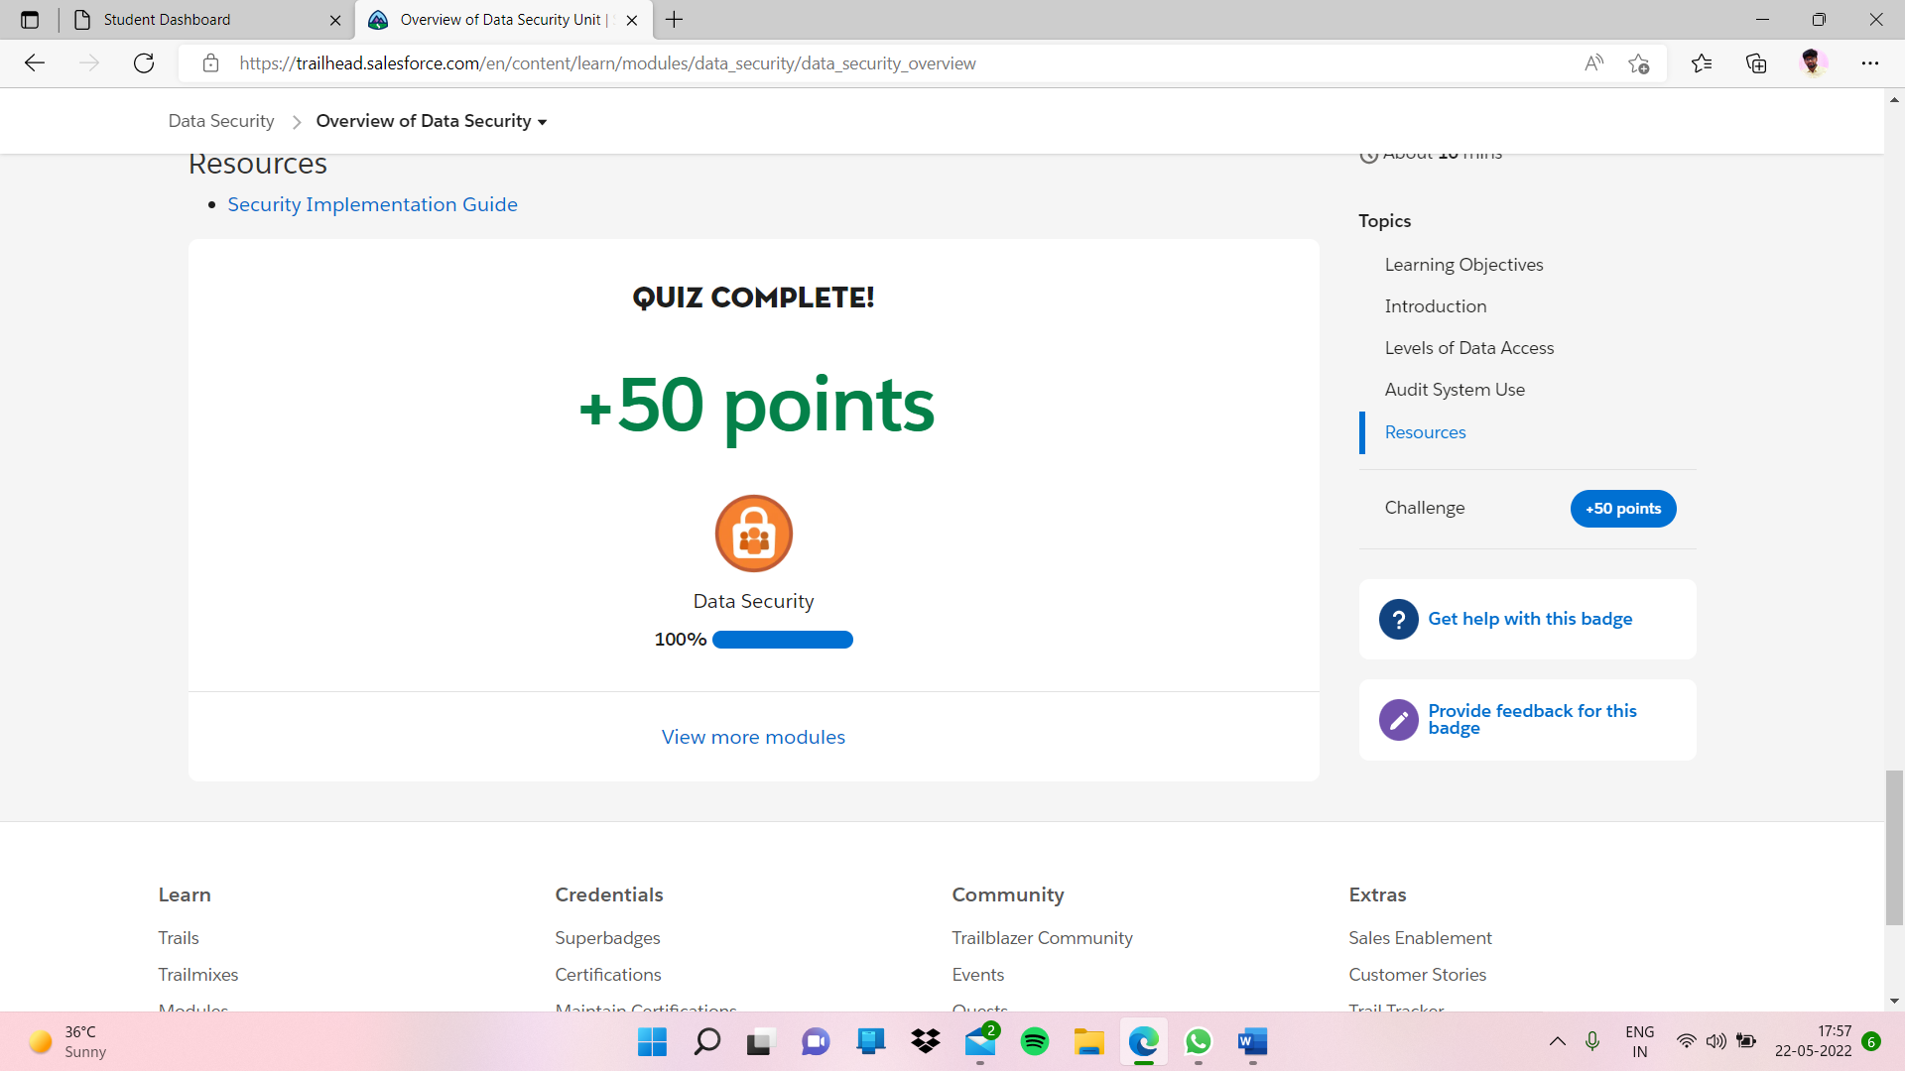

# **Control Access to the Org**

# **Control Access to Objects**

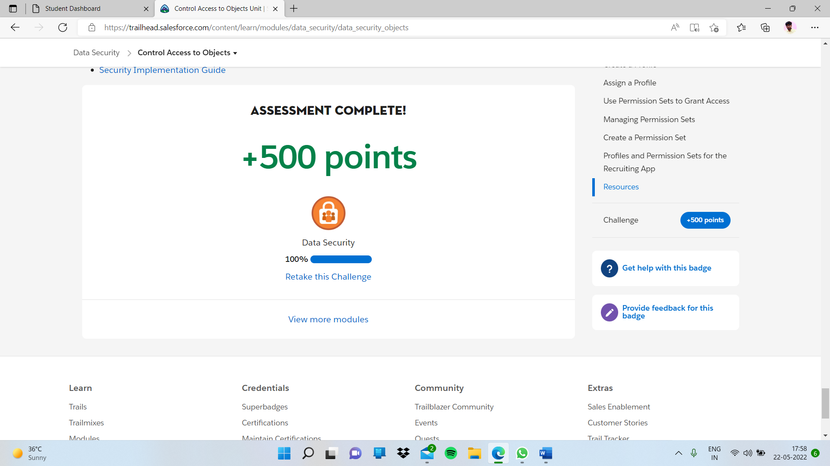

# **Control Access to Fields**

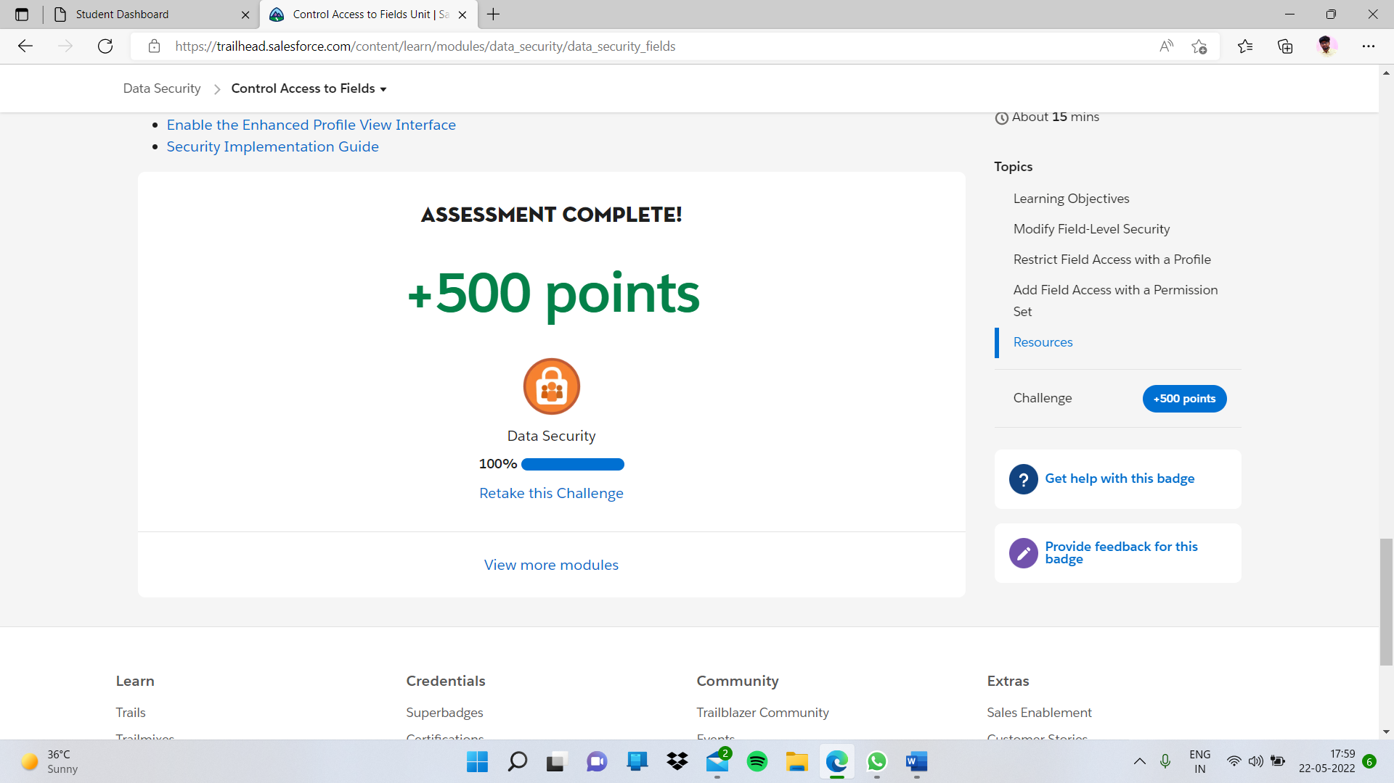

# **Control Access to Records**

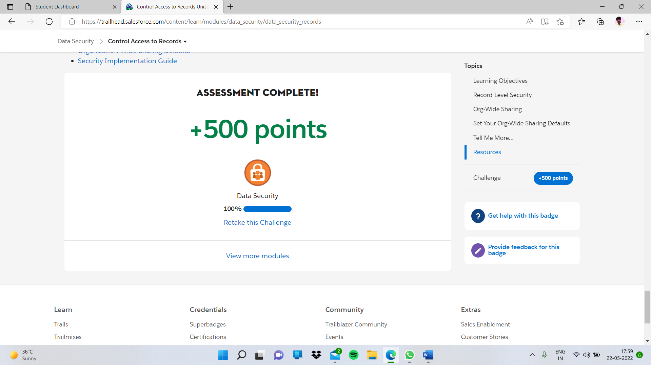

# **Create a Role Hierarchy**

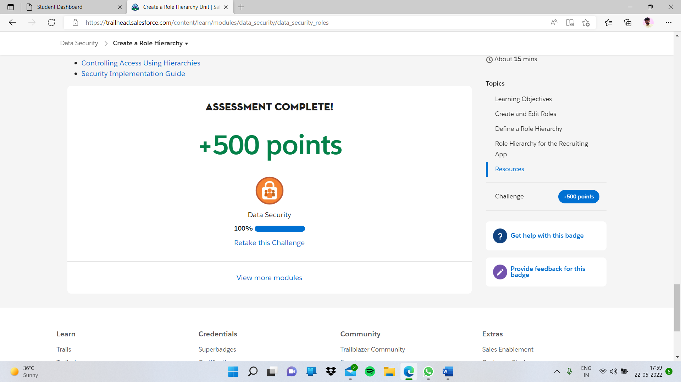

# **Define Sharing Rules**

# Data and Identity in Customer Data Platform

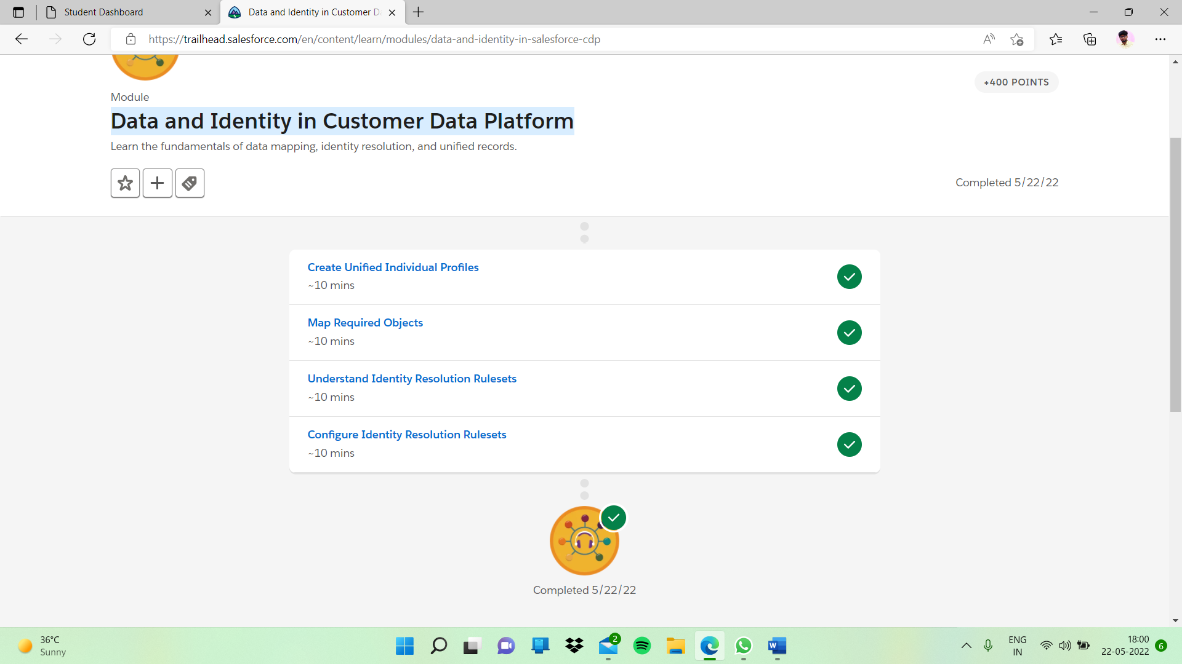

# **Create Unified Individual Profiles**

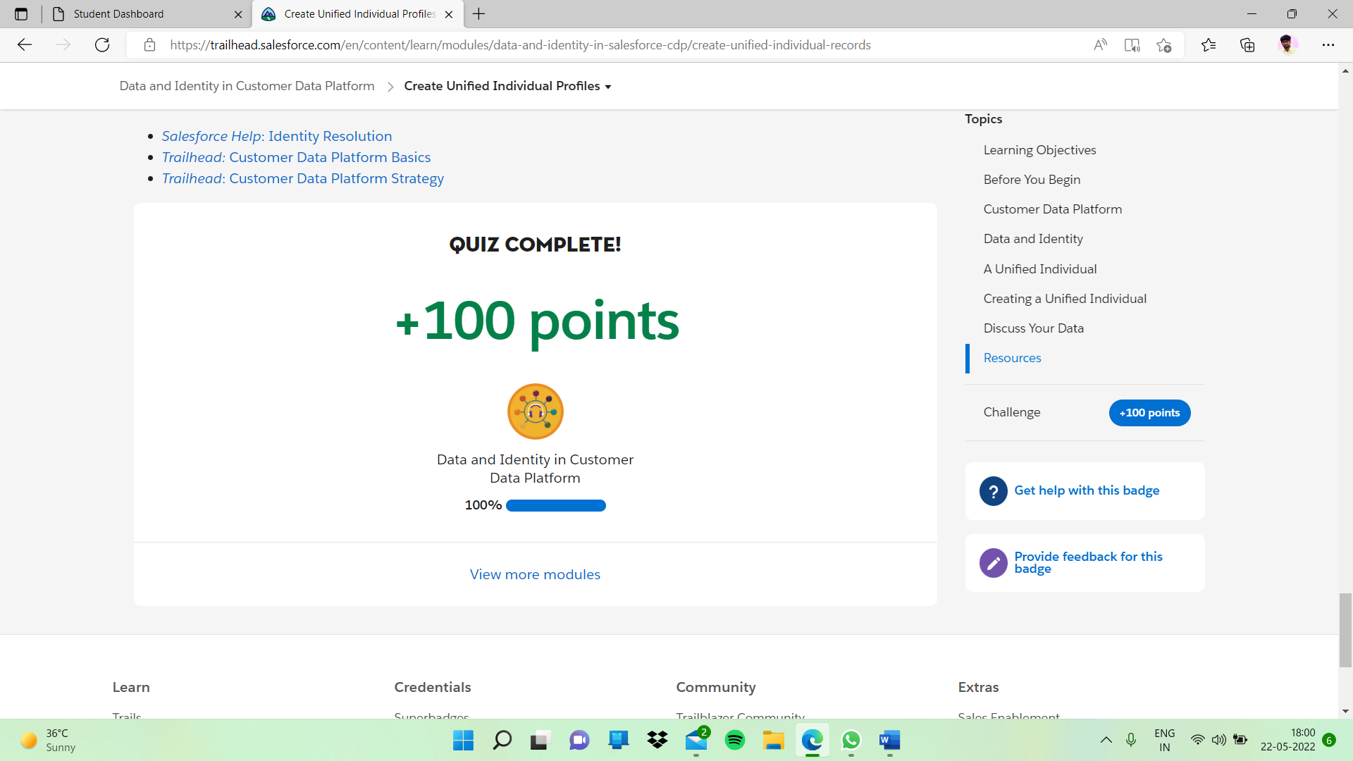

# **Map Required Objects**

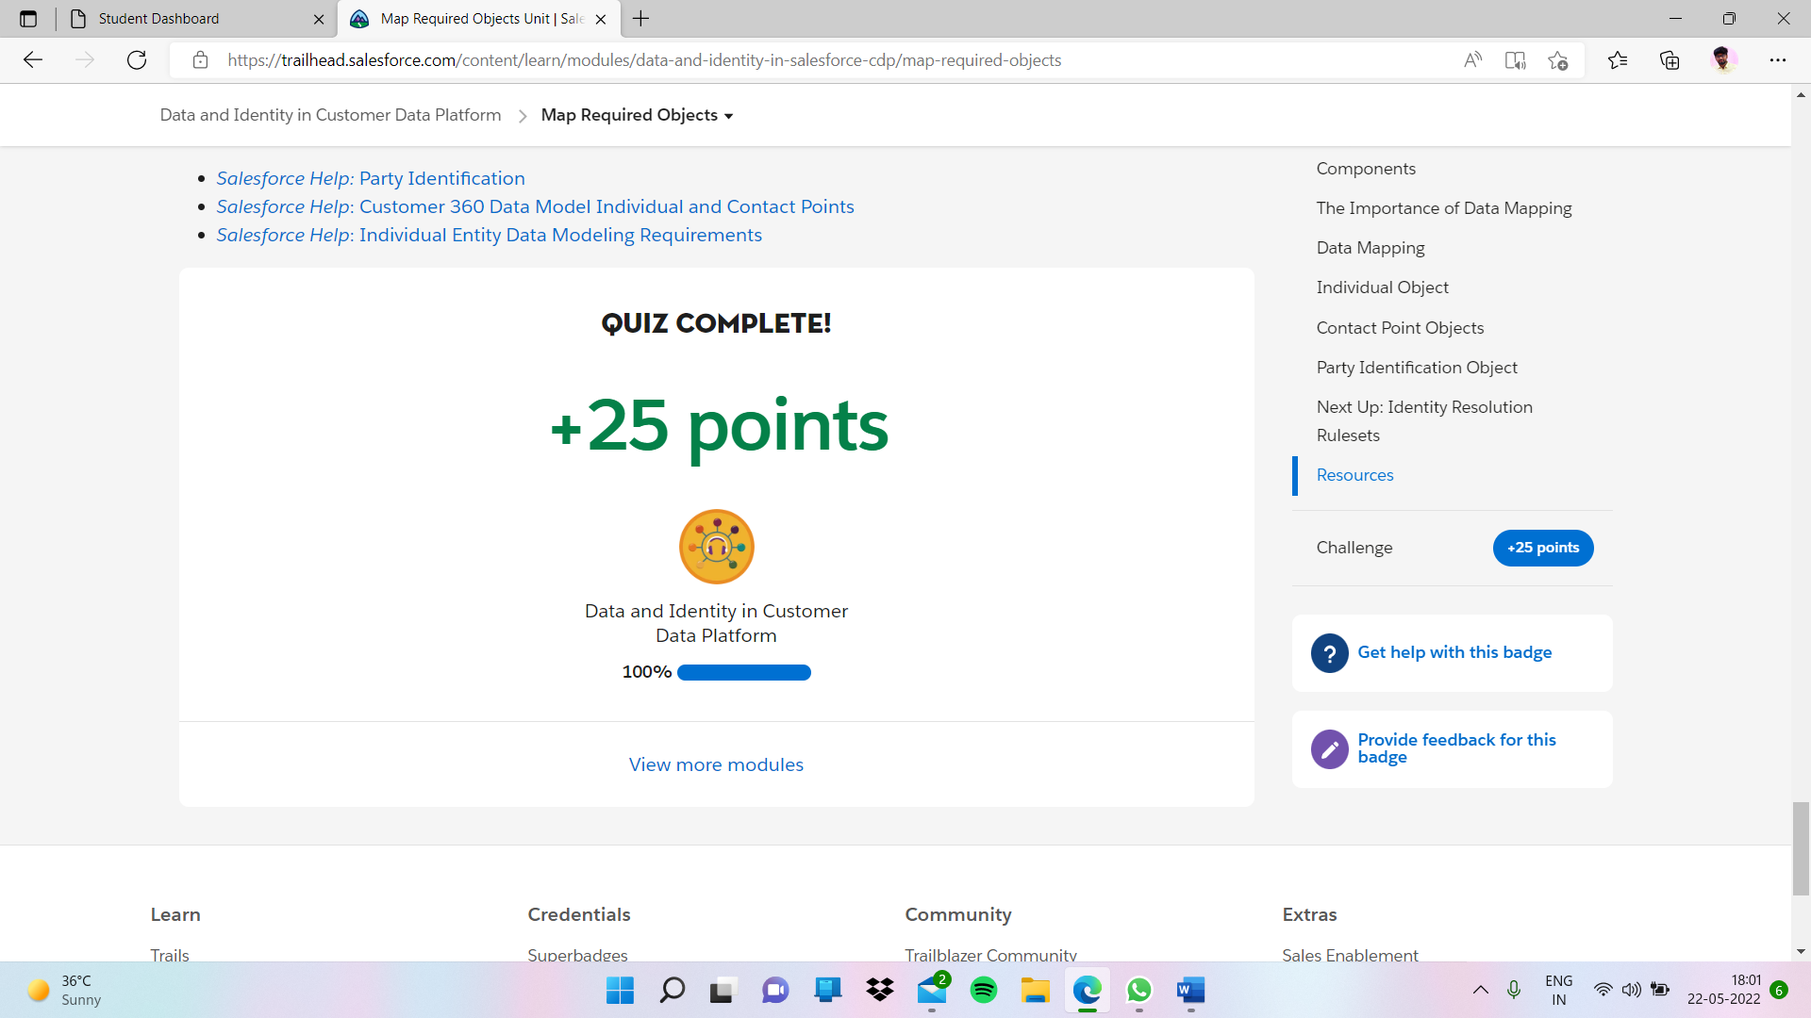

# **Understand Identity Resolution Rulesets**

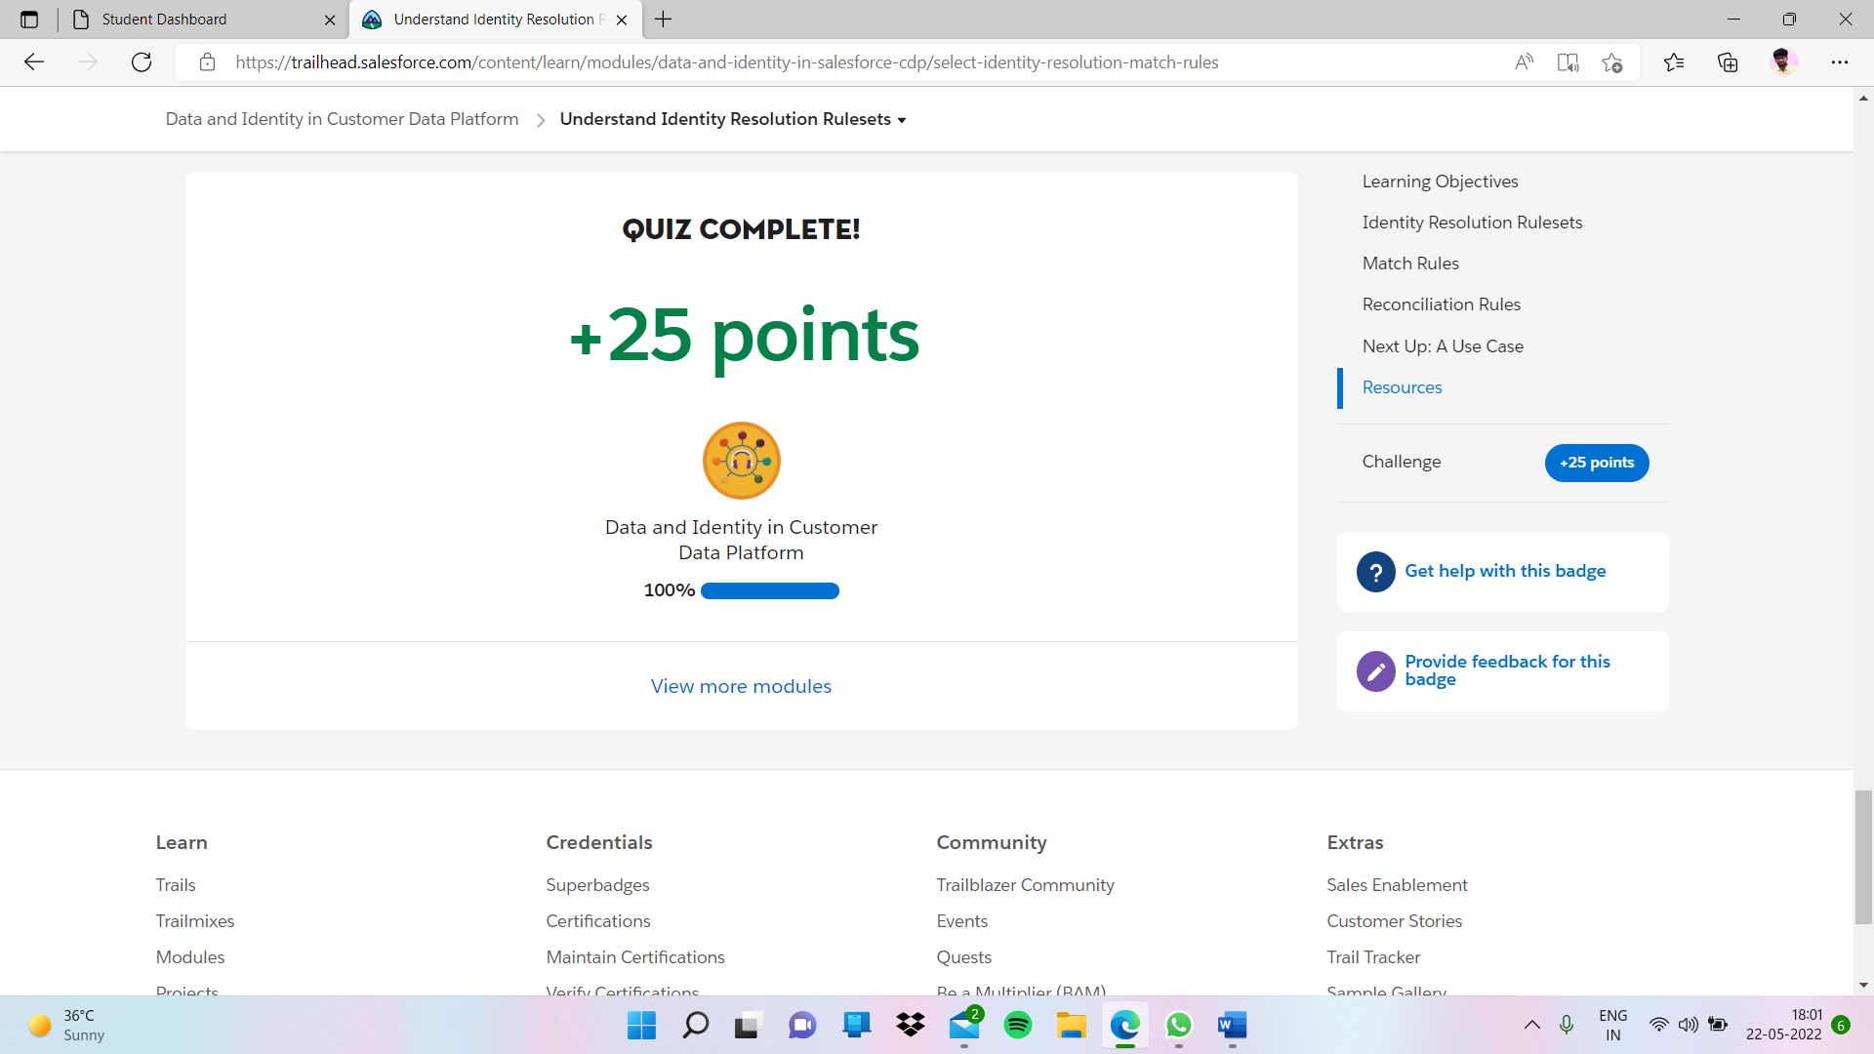

# **Configure Identity Resolution Rulesets**

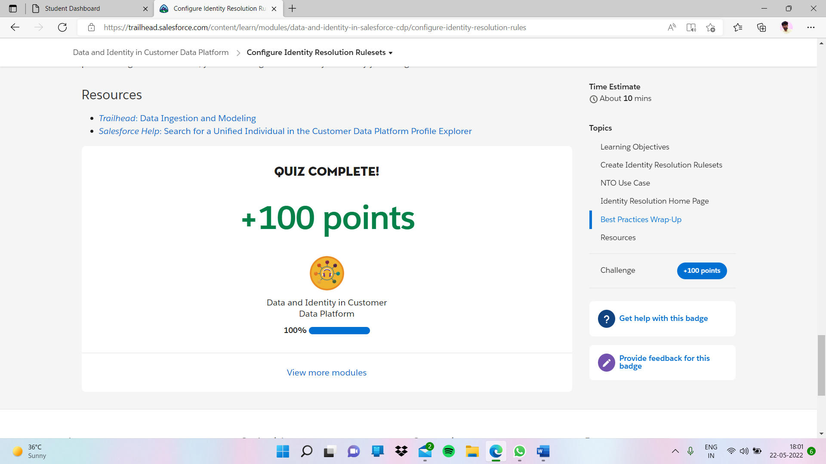

# User Authentication

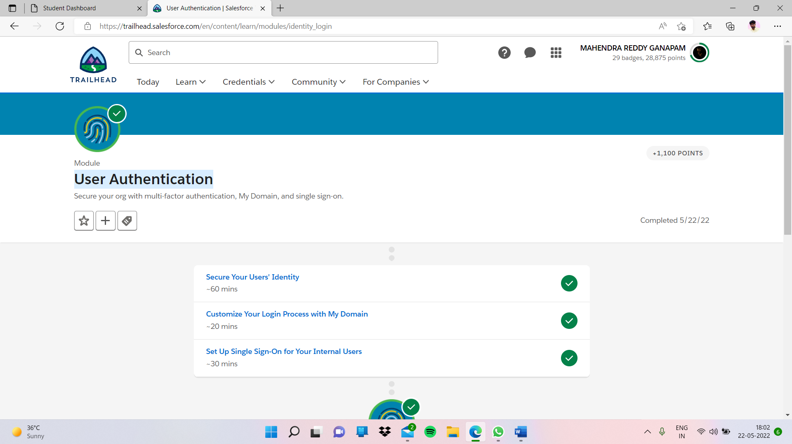

# **Secure Your Users' Identity**

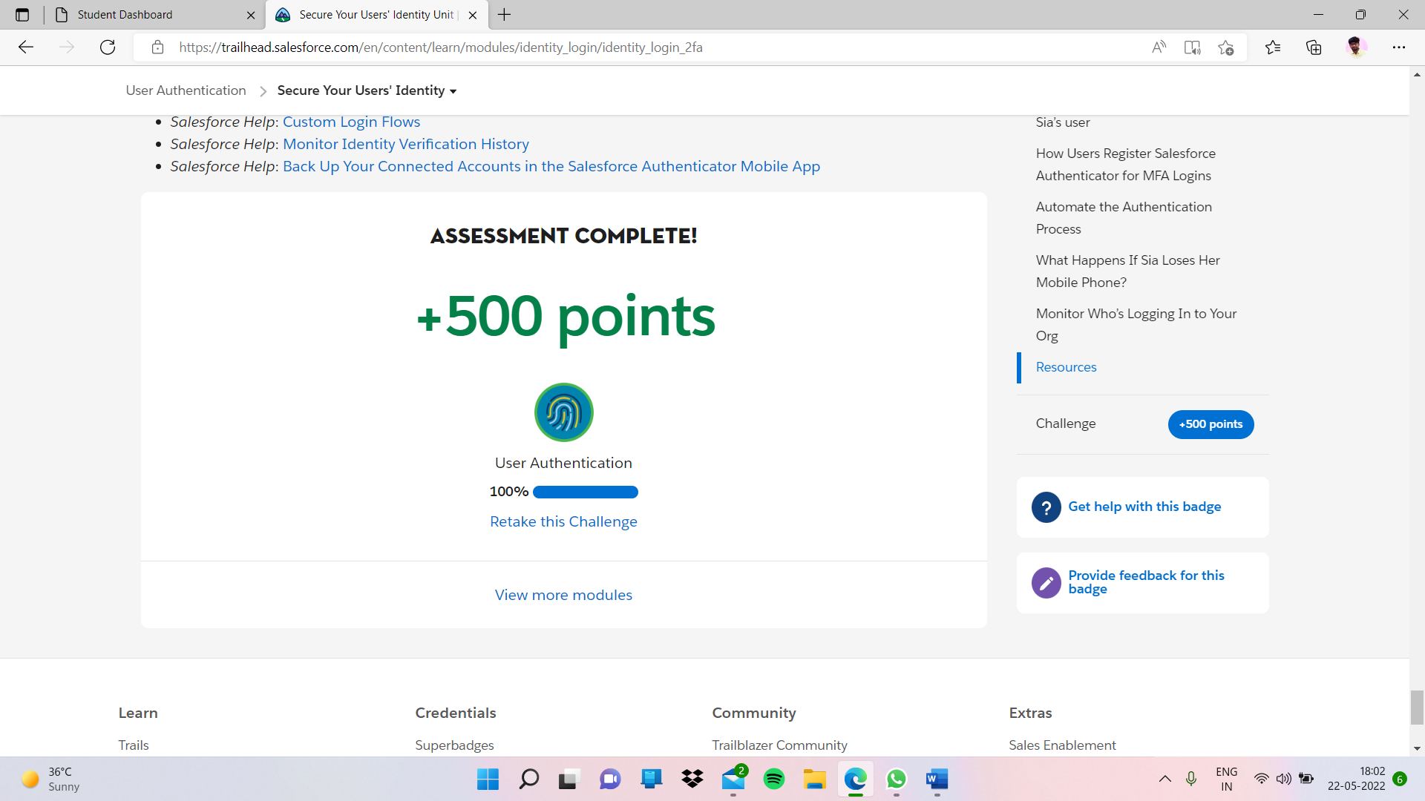

# **Customize Your Login Process with My Domain**

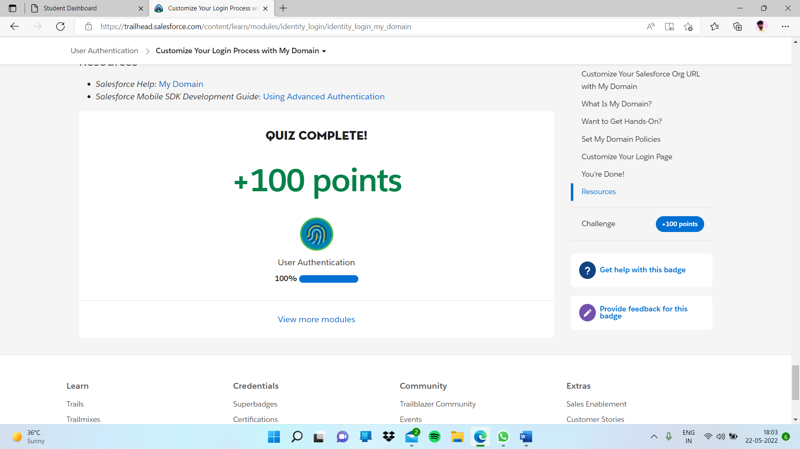

# **Set Up Single Sign-On for Your Internal Users**

